Enterprise Financial Platform for MFS, Digital Banking & Payments
Board-Style Technical Product Overview Report
Technical Architecture | Operational Model | Deployment Strategy | Ownership Model | Platform Maturity
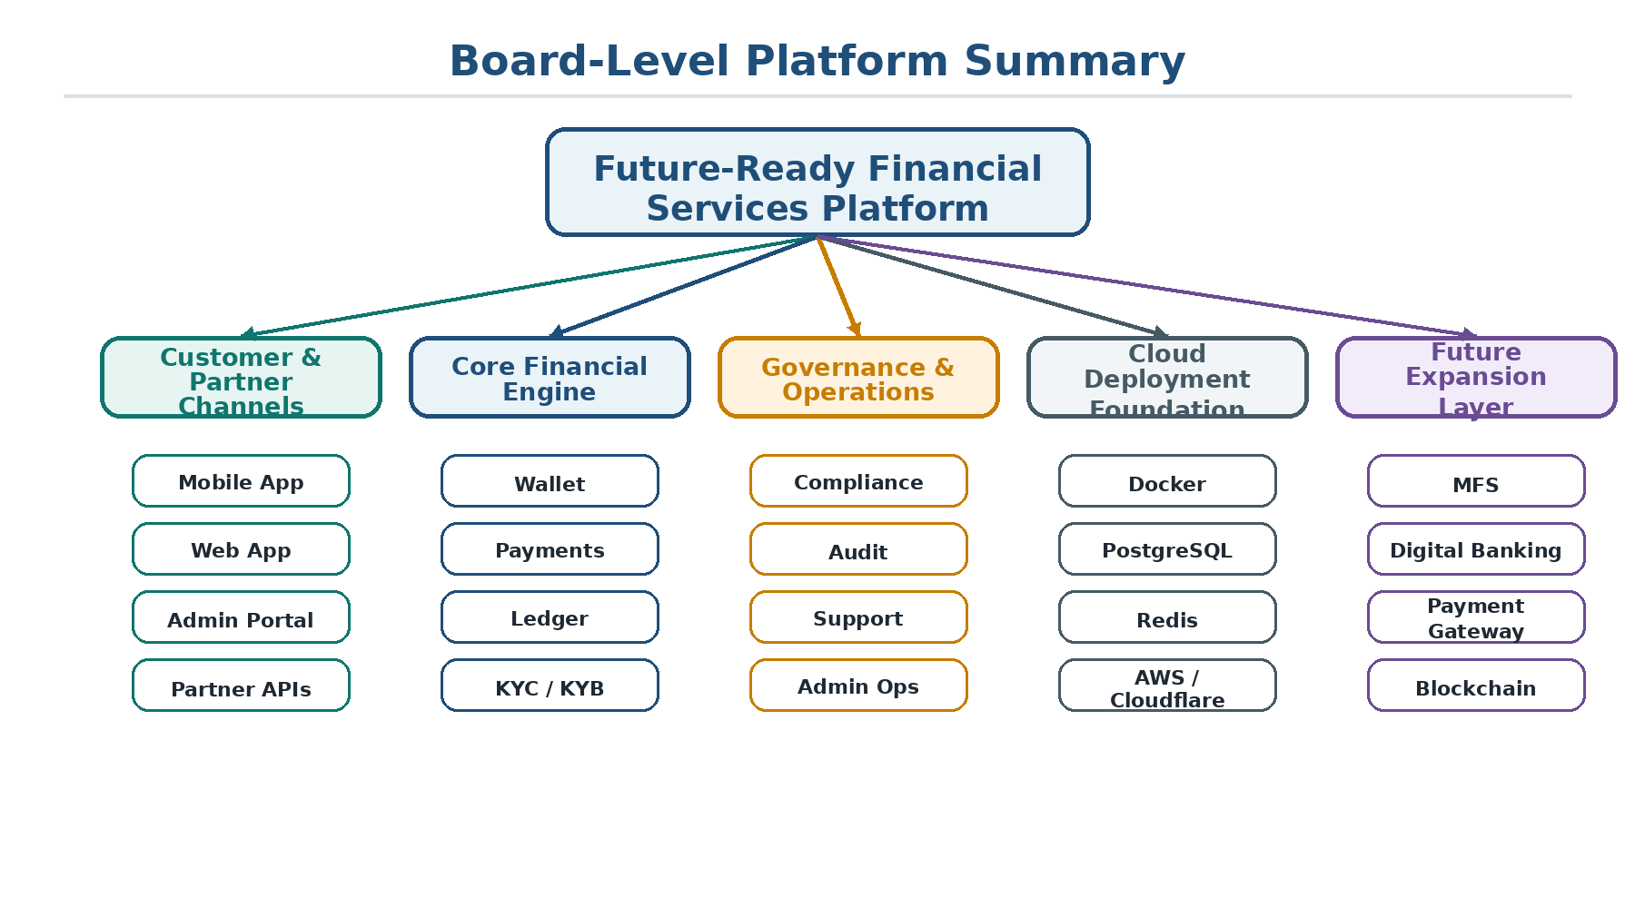
Figure 1: Board-level platform summary
Scope: MFS, Digital Banking, Payment Gateway, Wallet Infrastructure, Compliance Operations, and Future Blockchain Enablement

Table of Contents
- 1. Executive Summary
- 2. Platform Overview
- 3. Technical Architecture
- 4. Operational Model
- 5. Deployment Strategy
- 6. Ownership Model
- 7. Platform Maturity and Future Scope
- 8. Board-Level Conclusion

1. Executive Summary
This report presents a board-style technical product overview of a modular financial services platform built around digital wallet, payments, KYC/KYB, compliance screening, ledger accounting, support operations, administrative control, deployment readiness, and future blockchain enablement.
The platform can be positioned as a global-ready, API-driven fintech foundation suitable for Mobile Financial Services (MFS), digital banking, payment gateway operations, wallet-led financial services, embedded finance, and future blockchain-enabled financial infrastructure.

1.1 Strategic Positioning
- A unified backend for wallet, payments, compliance, accounting, support, and administration.
- A reusable platform core that can be configured according to client requirements.
- A modular product foundation for MFS, digital banking, payment gateway, and merchant payout use cases.
- A future-ready architecture with expansion potential for tokenized payment, blockchain settlement, and hybrid financial flows.
Dimension | Platform Positioning
Primary value | Reusable fintech platform core for multiple client-facing financial service models.
Technical identity | NestJS, PostgreSQL, TypeORM, Redis, Docker, cloud-ready deployment assets.
Commercial fit | MFS, digital wallet, digital banking, payment gateway, merchant payout, and compliance-driven fintech.
Future direction | Blockchain enablement, tokenized wallet models, smart contract automation, and hybrid fiat/digital asset flows.

2. Platform Overview
The platform is structured as an end-to-end financial technology foundation. It combines customer access, identity verification, wallet infrastructure, transaction processing, accounting control, compliance review, support operations, and cloud deployment readiness into one extensible backend.

2.1 Core Product Domains
- Authentication and user management for secure customer and admin access.
- Wallet and balance management for stored-value account operations.
- Payments and payout processing for incoming and outgoing money movement.
- Ledger and accounting workflows for financial traceability and operational control.
- KYC/KYB onboarding and sanctions screening for compliance-ready customer lifecycle management.
- Support, ticketing, audit logs, event logs, and admin operations for platform governance.
- Deployment and infrastructure assets for cloud-based implementation and operational rollout.

2.2 Product Conversion Potential
Dimension | Platform Positioning
MFS platform | Customer wallets, top-up, transfers, payouts, KYC, support, and operational administration.
Digital banking core | Customer onboarding, wallet/account infrastructure, ledger, compliance, audit, and lifecycle control.
Payment gateway | Payment instructions, provider transactions, webhook events, fee calculation, payouts, and merchant operations.
Compliance fintech | KYC/KYB, sanctions screening, risk scoring, review decisions, audit trail, and case handling.
Blockchain-ready fintech | Future expansion toward tokenized payment, smart contract automation, and on-chain settlement use cases.

3. Technical Architecture
The technical architecture follows a modular API-driven design. Each business capability is separated into a dedicated application domain, while shared infrastructure components support persistence, caching, document storage, provider integration, notifications, and auditability.
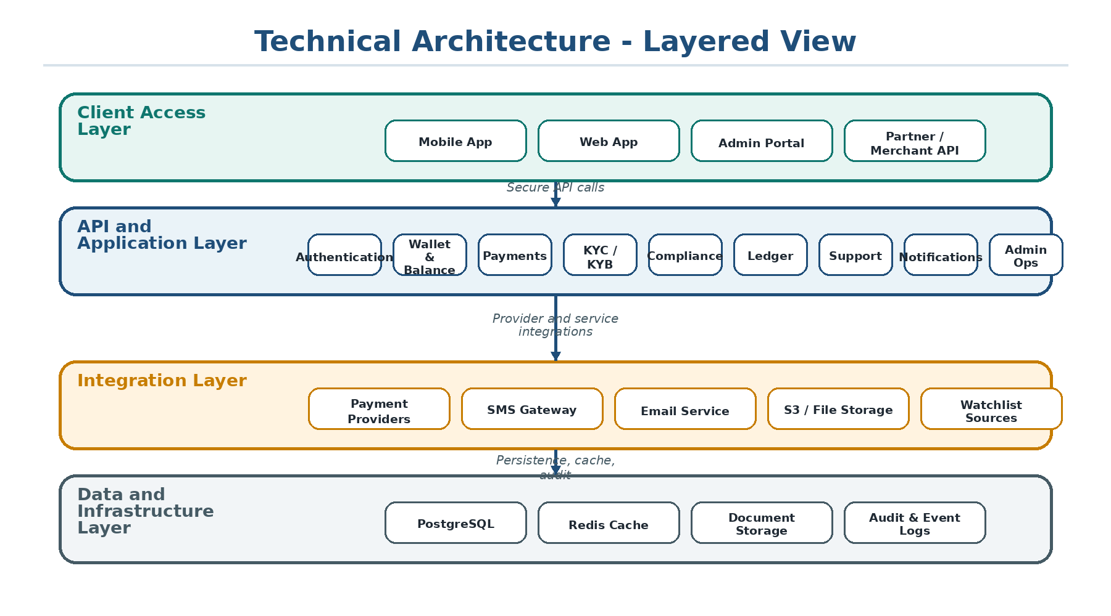
Figure 2: Layered technical architecture

3.1 Architecture Layers
- Client Access Layer: mobile application, web application, admin portal, and partner or merchant API clients.
- API and Application Layer: authentication, wallet, payments, KYC/KYB, compliance, ledger, support, notifications, and admin operations.
- Integration Layer: payment providers, SMS, email, file storage, and screening sources.
- Data and Infrastructure Layer: PostgreSQL, Redis, document storage, audit logs, and event logs.

4. Operational Model
The operational model covers the complete customer and transaction lifecycle. A user can register, verify identity, complete KYC/KYB requirements, receive a wallet, perform financial transactions, receive notifications, and interact with support.
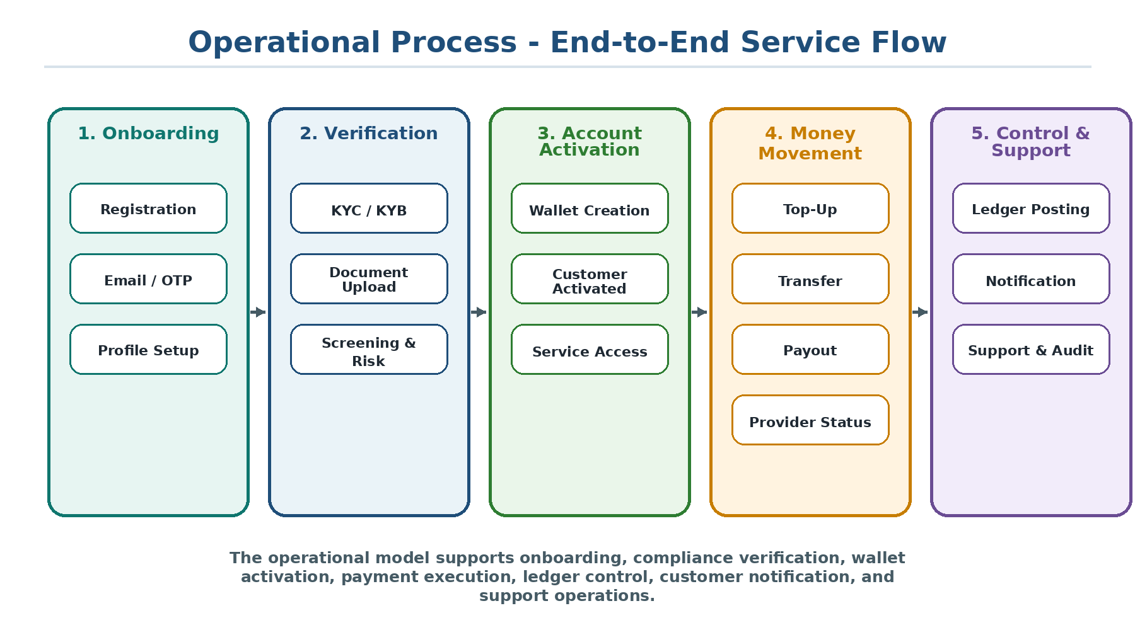
Figure 3: End-to-end operational process flow

4.1 Operating Capabilities
- Customer onboarding, OTP verification, profile setup, KYC/KYB submission, and document upload.
- Compliance screening, sanctions checks, risk scoring, manual review, approval, and request-for-information workflows.
- Wallet activation, top-up, wallet-to-wallet transfer, payout, payment provider status update, and transaction history.
- Ledger posting, notification delivery, support ticketing, audit visibility, and admin operations.

4.2 Money Movement and Accounting Flow
Money movement is coordinated across the API, wallet service, payment service, provider integration, ledger service, notification layer, and admin operations. This gives the platform a structured flow for transaction execution and financial traceability.
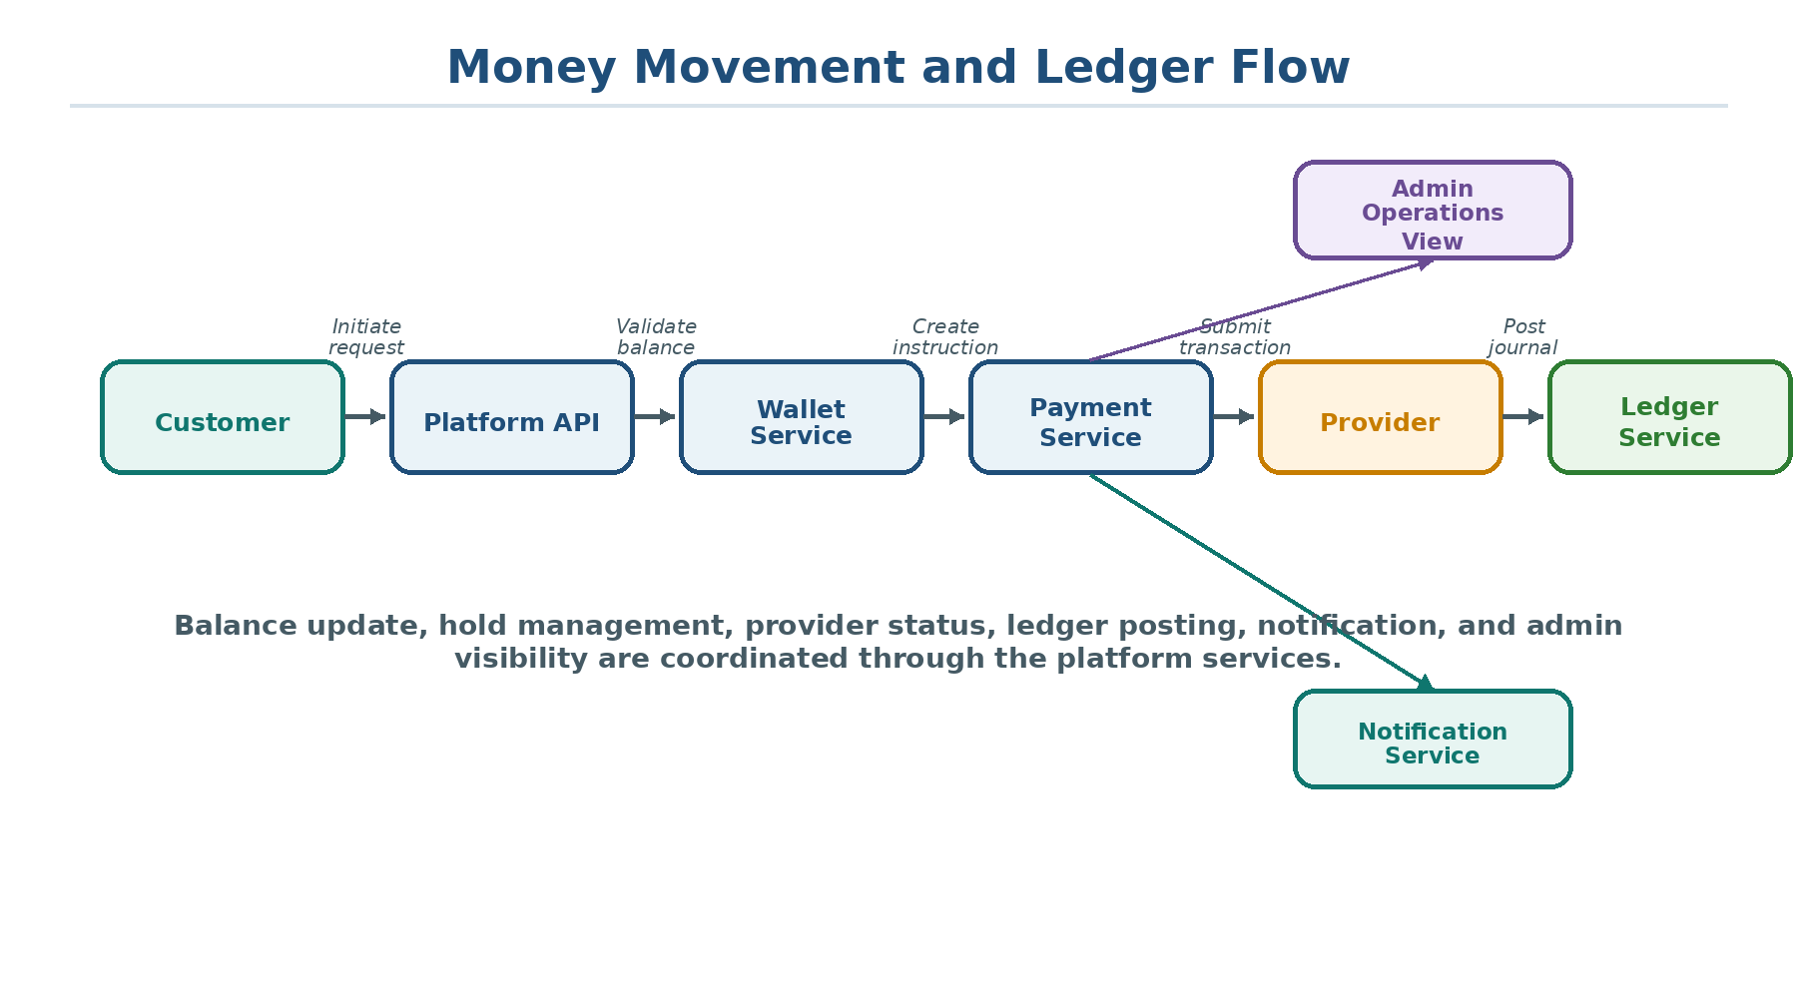
Figure 4: Payment and ledger flow
- Top-up, transfer, and payout operations are initiated through the platform API.
- Wallet validation and balance state handling support controlled financial movement.
- Payment instructions and provider transaction records support provider-level tracking.
- Ledger posting aligns financial activity with accounting control and auditability.
- Notifications and admin views provide operational visibility after transaction execution.

5. Deployment Strategy
The platform is designed for modern cloud-native deployment. It includes containerization and infrastructure-related assets that make it suitable for dedicated client deployment, enterprise-hosted implementation, or cloud-managed financial service environments.
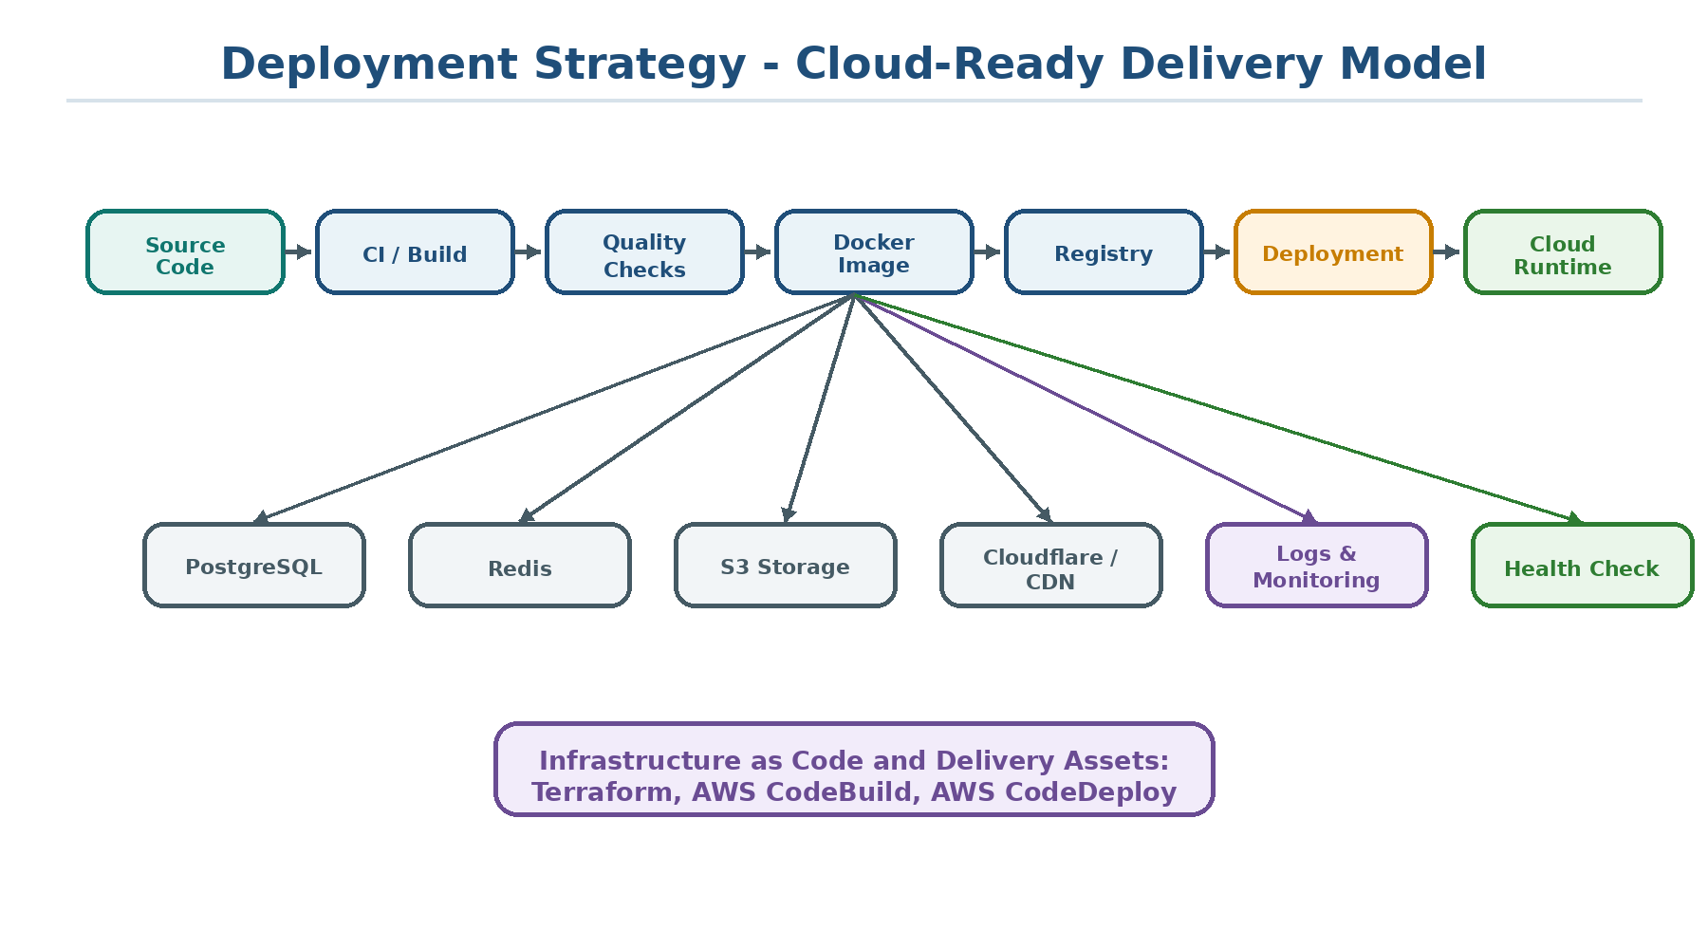
Figure 5: Cloud-ready deployment model

5.1 Deployment Characteristics
- Docker-ready application runtime.
- AWS CodeBuild and CodeDeploy support for delivery automation.
- Terraform-related infrastructure assets for repeatable environment setup.
- PostgreSQL, Redis, S3-compatible storage, and Cloudflare-ready deployment patterns.
- Health/status endpoint for service readiness checks.
- Flexible deployment as a dedicated client instance, white-label platform, digital banking backend, or payment operations backend.

6. Ownership Model
The platform supports clear ownership boundaries across product, engineering, operations, compliance, finance, and support teams. This helps client organizations define accountability across different parts of a financial services business.
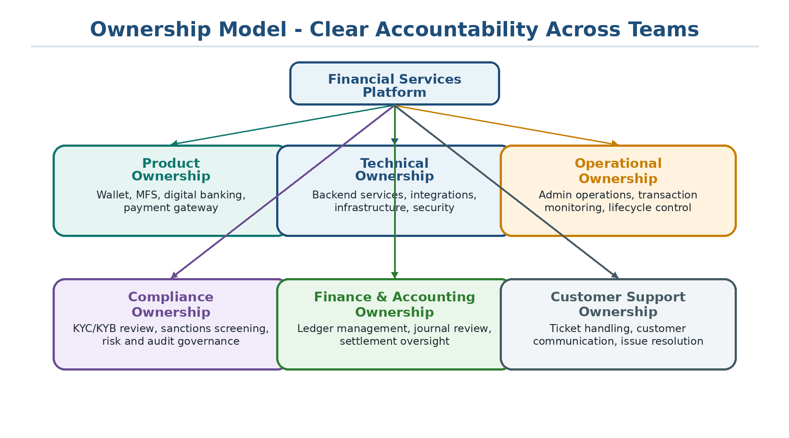
Figure 6: Platform ownership model

6.1 Ownership Domains
- Product ownership: wallet, MFS, digital banking, payment gateway, merchant platform, and future product extensions.
- Technical ownership: backend services, provider integrations, infrastructure, authentication, and security layers.
- Operational ownership: customer lifecycle control, admin operations, transaction monitoring, and service workflows.
- Compliance ownership: KYC/KYB review, sanctions screening, risk review, audit governance, and case handling.
- Finance and accounting ownership: ledger management, journal review, settlement oversight, and financial traceability.
- Support ownership: ticket handling, customer communication, and issue resolution.

7. Platform Maturity and Future Scope
The platform can be presented as a complete and feature-rich financial product foundation. It already contains the major modules needed for wallet operations, payments, KYC/KYB, compliance screening, accounting, support, administration, and cloud deployment.
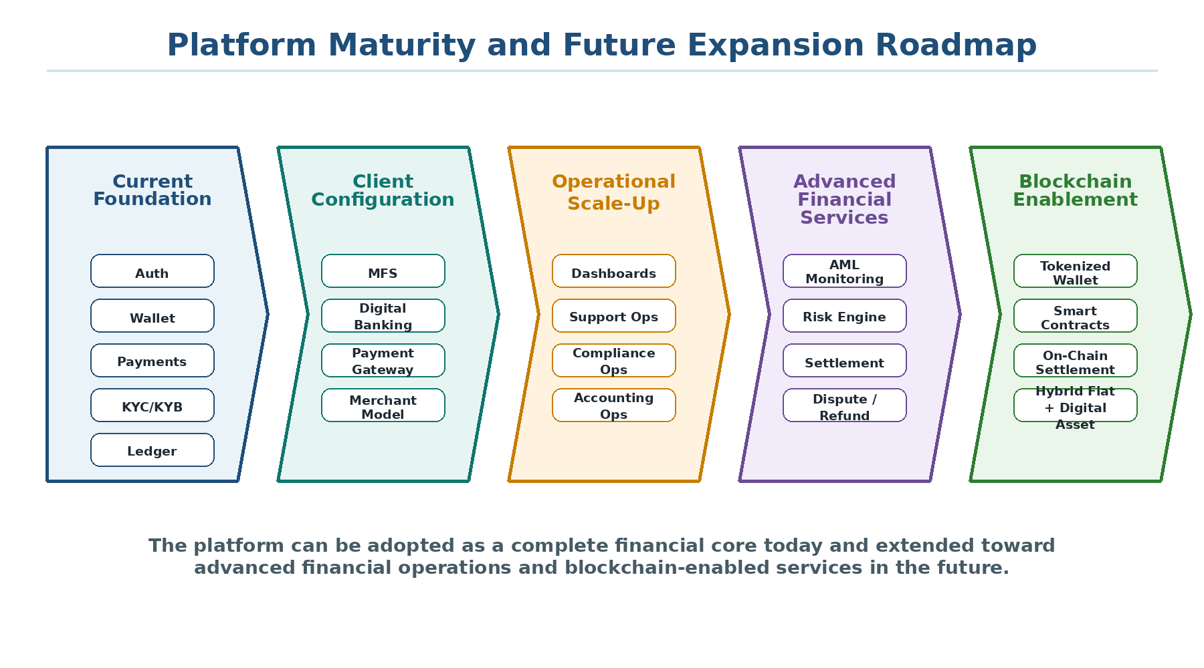
Figure 7: Platform maturity and future expansion roadmap

7.1 Current Platform Status
- Complete financial platform foundation with identity, wallet, payments, compliance, accounting, support, and administration.
- Suitable for configurable deployment across MFS, digital banking, payment gateway, and wallet-led fintech models.
- Feature-rich architecture that can support client-specific product packaging and phased implementation.
- Cloud-ready deployment structure with supporting infrastructure and integration assets.

7.2 Future Blockchain Enablement
- Blockchain-backed wallet infrastructure and tokenized balance representation.
- On-chain transaction recording for selected financial events.
- Stablecoin-based payment, remittance, and cross-border settlement use cases.
- Smart contract-based payment automation and programmable treasury workflows.
- Merchant settlement using digital assets or hybrid fiat and digital asset models.
- Blockchain-based identity or credential verification layers and external network integrations.

8. Board-Level Conclusion
This platform represents a strong, modular, and commercially adaptable financial technology foundation. It combines customer onboarding, wallet infrastructure, transaction processing, compliance workflows, ledger accounting, support operations, administrative control, and deployment readiness in one extensible backend architecture.
From a board-level and client-facing perspective, the platform can be confidently positioned as a future-ready financial services core that can be configured into MFS, digital banking, payment gateway, wallet-led fintech, compliance-driven financial applications, and future blockchain-enabled financial solutions.
Dimension | Platform Positioning
Product message | A unified, configurable fintech core for multiple financial service models.
Technical message | A modular API-driven architecture with wallet, payments, KYC/KYB, compliance, ledger, support, and admin domains.
Client message | The platform can be adapted based on business requirements without rebuilding the core system.
Future message | The product is positioned for blockchain enablement and advanced digital finance expansion.

